Jenkins-Style Parameterized Lambda Deployment Using AWS Native Services (PoC)

1. Overview
This document describes a Proof of Concept (PoC) to replace a Jenkins “Build with Parameters” pipeline with AWS-native services, while still supporting dynamic user inputs at runtime.
The solution enables on-demand deployment of Python AWS Lambda code using the following user-provided parameters:
- Lambda function name
- AWS region
- GitHub repository (private)
- Git branch
The entire flow is implemented without Jenkins, using managed AWS services only.

2. Problem Statement
Jenkins provides a convenient UI for:
- Manual pipeline triggers
- Dropdowns / parameters
- Shell-based deployment logic
However, Jenkins introduces:
- Operational overhead (server, plugins, security patches)
- Credential management complexity
- Scaling and availability concerns
AWS native CI/CD services do not provide a Jenkins-style UI, but they support parameterized execution via APIs, which is more secure and automation-friendly.
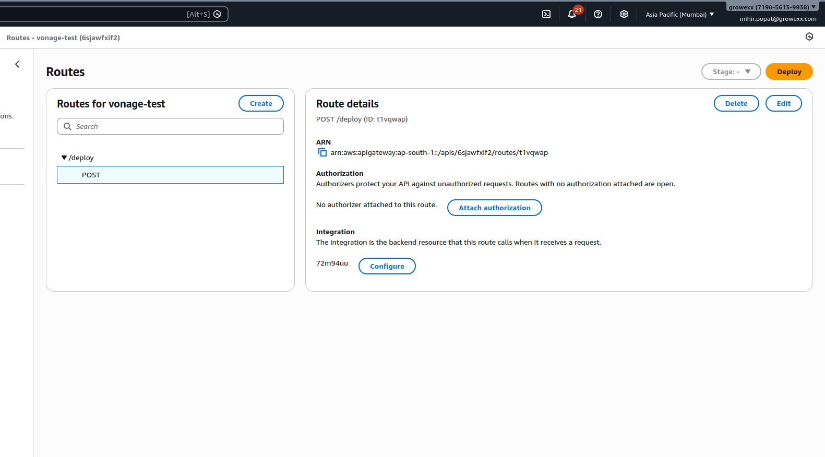

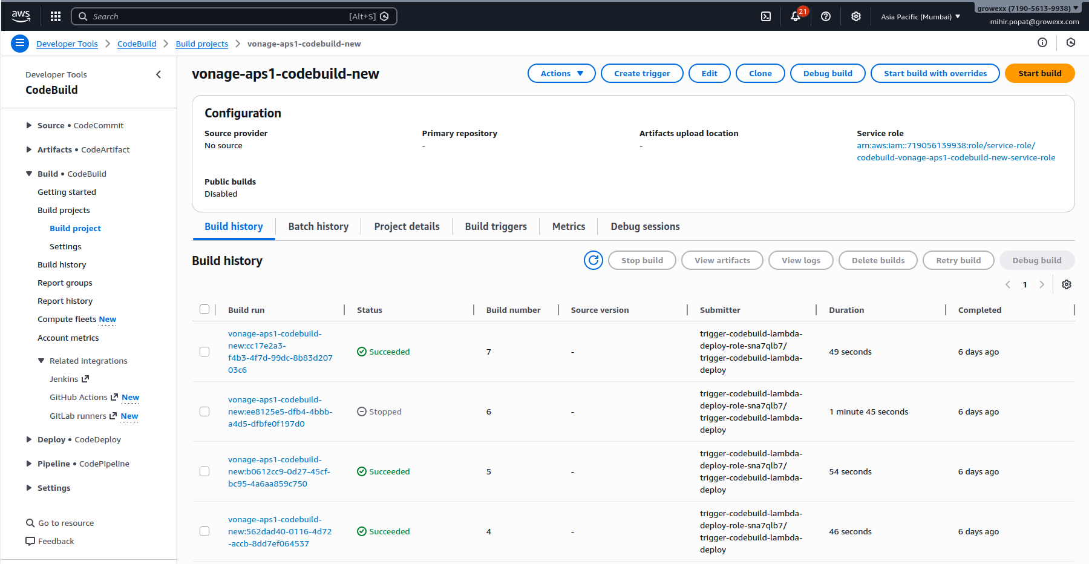
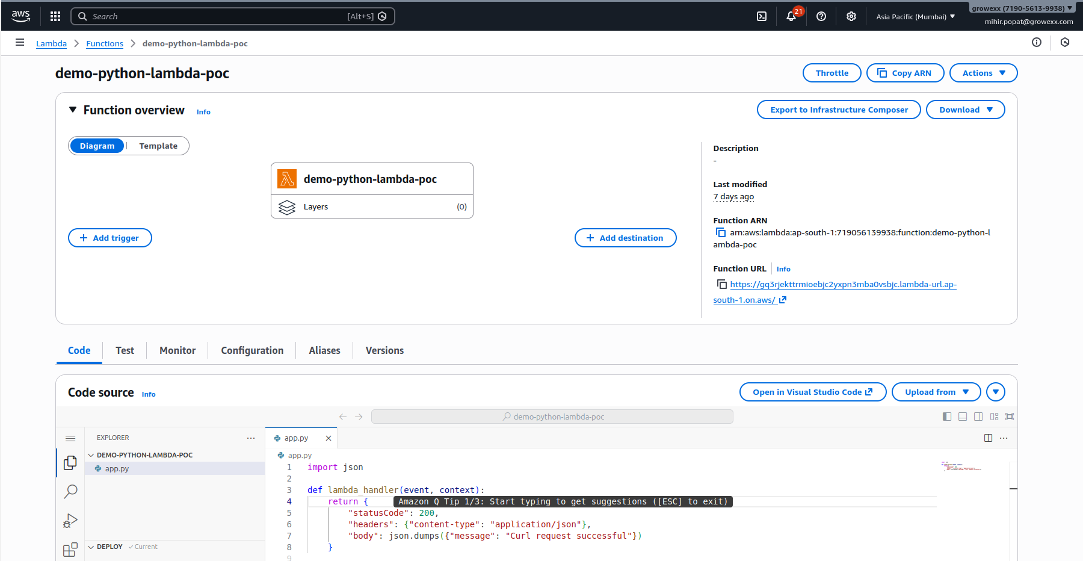

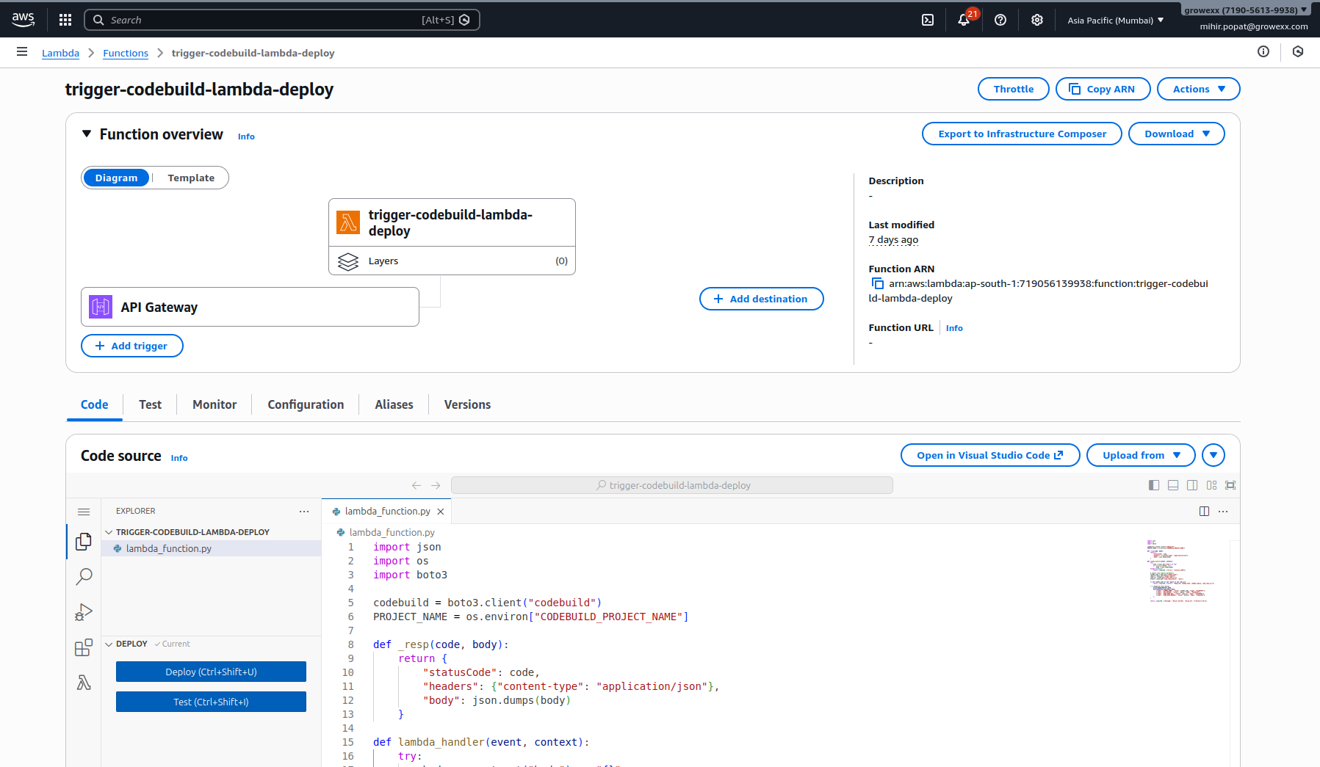

Buildspec.yml file
version: 0.2

env:
secrets-manager:
# SecretName:jsonKey
GITHUB_TOKEN: "github/poc/token:token"

phases:
install:
runtime-versions:
python: 3.11
commands:
- yum install -y git zip

pre_build:
commands:
- echo "LAMBDA_NAME=$LAMBDA_NAME"
- echo "AWS_REGION=$AWS_REGION"
- echo "CODE_REPO_URL=$CODE_REPO_URL"
- echo "CODE_REPO_BRANCH=$CODE_REPO_BRANCH"

# Clone private GitHub repo using token
- AUTH_REPO_URL=$(echo "$CODE_REPO_URL" | sed "s#https://#https://$GITHUB_TOKEN@#")
- rm -rf code || true
- git clone --branch "$CODE_REPO_BRANCH" "$AUTH_REPO_URL" code

build:
commands:
- cd code
- mkdir -p package
- if [ -f requirements.txt ]; then pip install -r requirements.txt -t package/; fi
- cp -r src/* package/
- cd package
- zip -r ../lambda.zip .
- cd ..

- echo "DEBUG LAMBDA_NAME=[$LAMBDA_NAME] AWS_REGION=[$AWS_REGION]"
- aws lambda update-function-code --function-name "$LAMBDA_NAME" --zip-file "fileb://lambda.zip" --region "$AWS_REGION"

3. Solution Summary
This PoC implements a Jenkins-equivalent parameterized pipeline using:
- Amazon API Gateway – entry point for user input
- AWS Lambda – trigger function to process inputs
- AWS CodeBuild – build & deployment engine
- AWS Secrets Manager – secure GitHub token storage
- GitHub – private Lambda code repository
User inputs are passed at runtime, just like Jenkins parameters.

4. High-Level Architecture
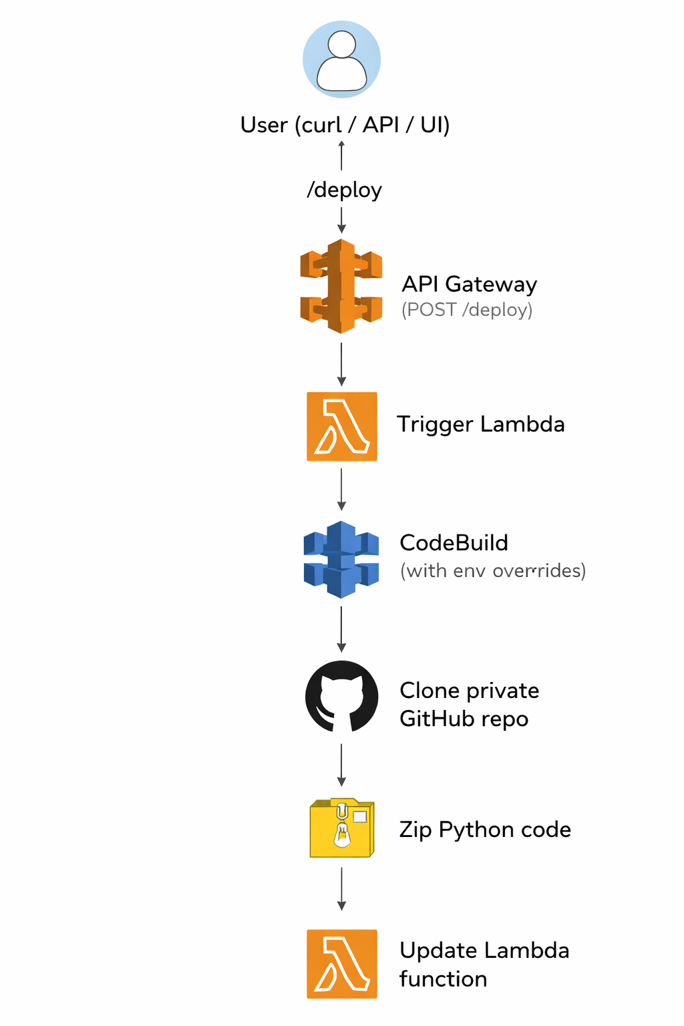
Flow
User (curl / API / UI)
↓
API Gateway (POST /deploy)
↓
Trigger Lambda
↓
CodeBuild (with env overrides)
↓
Clone private GitHub repo
↓
Zip Python code
↓
Update Lambda function

5. Repository Design

Repo-1: Pipeline Repository
Purpose: Holds deployment logic only.
Contents: buildspec.yml
This repository does not contain Lambda code.

Repo-2: Lambda Code Repository (Private)
Purpose: Holds Python Lambda source code.
Structure:
src/
app.py
requirements.txt

Handler: app.handler

6. User Inputs (Jenkins Parameter Equivalent)
The following values are provided per execution:
Parameter | Description
lambda_name | Target Lambda function name
lambda_region | AWS region
code_repo_url | Private GitHub repo URL
code_repo_branch | Git branch to deploy
These inputs are supplied as JSON to API Gateway.

7. Security Design

GitHub Authentication
- GitHub Personal Access Token (read-only)
- Stored securely in AWS Secrets Manager
- Injected into CodeBuild as a secret environment variable
- Never exposed in logs or plaintext
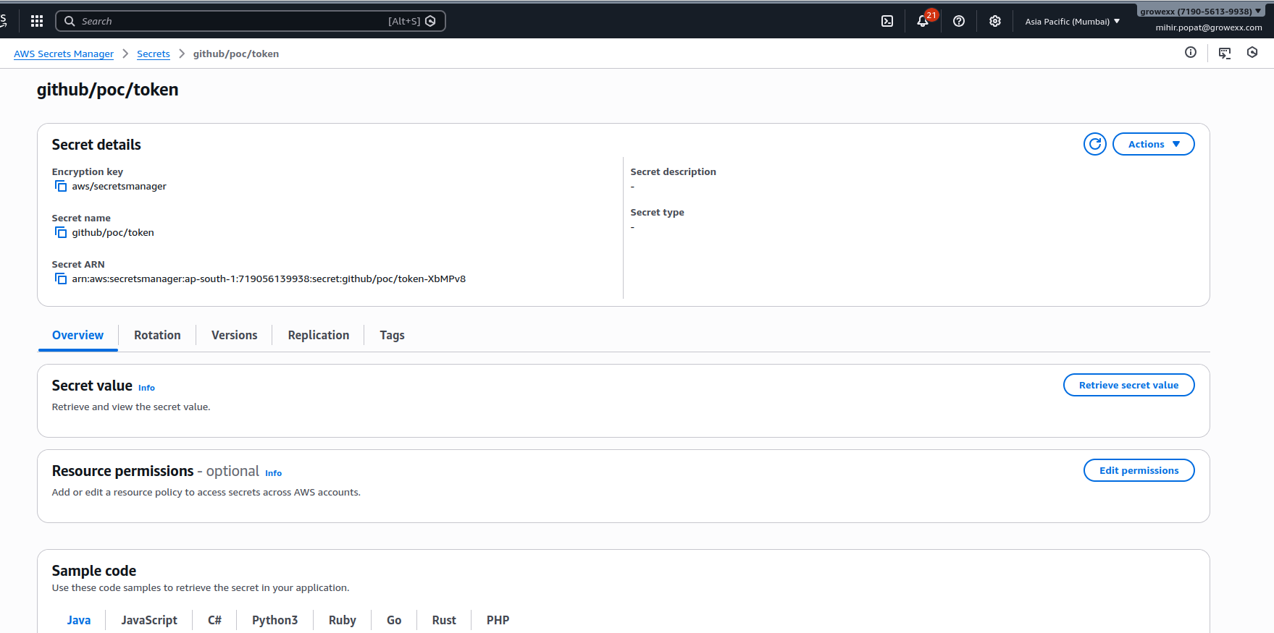

IAM Separation
- Trigger Lambda: codebuild:StartBuild
- CodeBuild:
  - lambda:UpdateFunctionCode
  - secretsmanager:GetSecretValue
  - CloudWatch Logs permissions

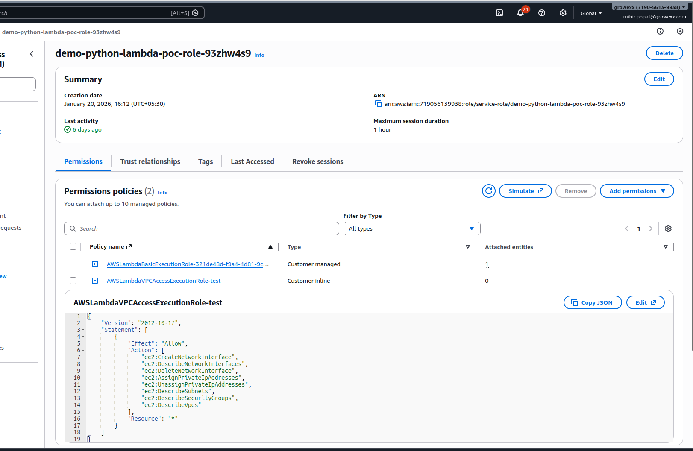

8. Build & Deployment Logic (CodeBuild)

Key Responsibilities
- Clone private GitHub repository
- Install dependencies
- Package Lambda code
- Deploy to the specified Lambda function and region

Deployment Command
aws lambda update-function-code \
--function-name "$LAMBDA_NAME" \
--zip-file fileb://lambda.zip \
--region "$AWS_REGION"

All variables are supplied dynamically per run.

9. API Contract

Endpoint : POST /deploy

Request Body

{

"lambda_name": "demo-python-lambda-poc",

"lambda_region": "ap-south-1",

"code_repo_url": "https://github.com/org/private-lambda-code-repo.git",

"code_repo_branch": "main"

}

Response

{

"message": "Build started",

"build_id": "poc-lambda-deploy:uuid"

}

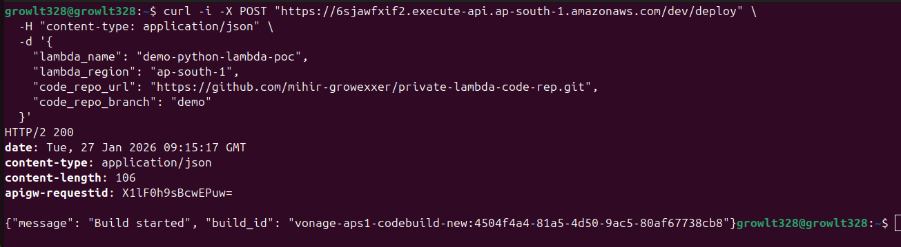

10. Execution Flow (Step-by-Step)
- User sends deployment request to API Gateway
- API Gateway invokes Trigger Lambda
- Trigger Lambda validates inputs
- Trigger Lambda starts CodeBuild with environment overrides
- CodeBuild:
  - Fetches GitHub token from Secrets Manager
  - Clones private repo
  - Packages code
  - Updates Lambda
- Logs are available in CloudWatch

11. Testing & Validation

Trigger Deployment

Verify
- CodeBuild build history
- CloudWatch logs
- Lambda “Last modified” timestamp
- Lambda invocation output

12. Limitations (PoC)
- No built-in UI dropdown (AWS is API-first)
- Manual JSON input required
- Single-step deployment (no approvals)

13. Future Enhancements
- Simple HTML UI with dropdowns (S3 + CloudFront)
- Step Functions for multi-stage workflows
- Manual approval steps
- GitHub Actions alternative
- IAM scope hardening
- Multi-account deployment support

